Asian Parliamentary Assembly
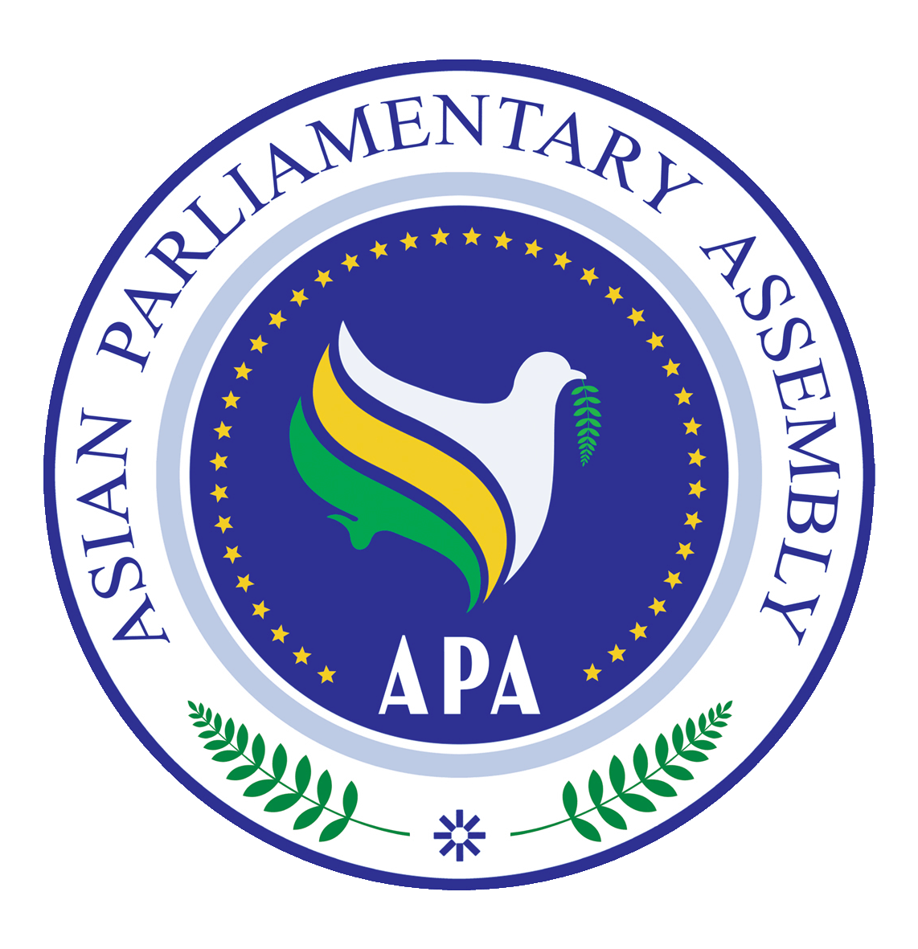 | Standing Committee on Budget and planning  (Virtual Meeting)  Moscow, Russian Federation  4 August2021 | 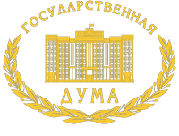
Registration Form
(7/24/2021 by APA Secretariat)
Delegation of: ………………………………
Name of Parliament

No. | First Name | Last Name | Position | Photo
Host Secretariat:  Email:  Fax :  Tel : | CC to APA Secretariat:  Email :secretariat@asianparliament.org  Fax : (+98-21) 33517408  Phone : (+98-21) 33517406-7

